## Microsoft Visual C++ Redistributable Software Package

Microsoft Visual C++ Redistributable software package is a prerequisite for Windows platform to run the application INP_T2_Demo_Windows.exe successfully. Incase this software package is not installed on the Windows platform, application will not launch, leading to a fatal error message as shown in Figure 7.

In such a scenario, install the Microsoft Visual C++ Redistributable software package using the link <https://www.microsoft.com/en-in/download/details.aspx?id=48145> and relaunch the application.

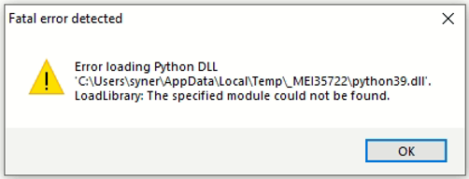

Figure 7: Error message for missing Microsoft Visual C++ Redistributable Software Package